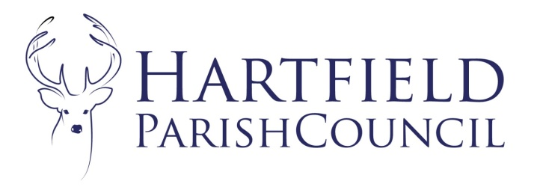
Clerk to the Council: Emma Fulham
Goods Yard House
Edenbridge Road, Hartfield, TN7 4JG
01342 822404
01892 771140
parishclerk@hartfieldonline.com

11th February 2020.

To Whom It May Concern

Reference: Hartfield Parish Council Grants.
Grants: The Parish Council will be awarding annual grants again this year upon written request, and has allocated in the budget an amount for grants. If there is a specific item or project that your organisation is struggling to finance, please write to me by 20th April 2020, using the enclosed application form. Please also enclose a copy of your latest set of accounts. The Parish Council consider all the grant requests together, so please try to ensure that your request is made by this date. If, however, you feel that you have sufficient funds to meet your requirements, please be assured that the funds will be allocated to those organisations that urgently need them.
Annual Parish Meeting: The Parish Council will be holding their Annual Parish Meeting on Monday 27th April 2020 at 7.30pm in the Village Hall. There will be a Chairman’s report and copies will be distributed of reports from Committee Chairmen, Parish Charities and Voluntary Organisations. There will be an opportunity for parishioners to ask questions or raise any issues that may need addressing. If you would like to submit a report of your organisation’s activities for distribution, please could you send it to me by 30th March 2020.
There will be refreshments and space for some local groups to have some stalls or displays in the village hall at the annual meeting to raise awareness of parish organisations and if this is something you would be interested in please contact me as soon as possible to reserve a space.
I hope that you will be able to attend and everyone will be welcome.
Many thanks.
Yours Sincerely

Emma Fulham
Clerk to Hartfield Parish Council.
Enc.

