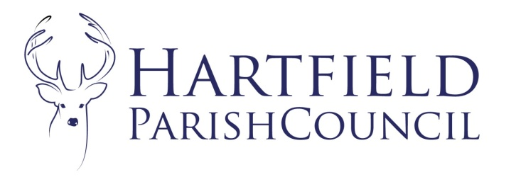
Clerk to the Council: Emma Fulham
Goods Yard House
Edenbridge Road, Hartfield, TN7 4JG
01342 822404
01892 771140
parishclerk@hartfieldonline.com

Minutes of the Hartfield Parish Council Strategy Committee Meeting held on 27th September 2021 at This followed the Finance meeting at 7:30pm at Goods Yard House.
Present: Cllrs Horner, Eastwood, Maude, Sanders and Nathan.
Absent: Cllrs Norman, Higgins, Beare, Emery, Colenutt, Smith, Burnett-Dick and Reed.
In Attendance: Emma Fulham Clerk to the Council.

- To accept apologies for absence.
Cllrs Higgins, Smith, Norman, Beare, Emery and Colenutt.
- To record Members’ Declarations of Interest in matters to be discussed.
The Chair reminded Cllrs to declare when necessary.
- To consider the strategic plan.
This had been circulated prior to the meeting.
The Council agreed some changes. The Clerk would re-circulate the plan for adoption by the Parish Council in due course and would put actions as agreed on future agendas.
- To consider projects and priorities for 2022/23 and beyond.
After some discussion on the outlined possible projects the Council agreed the following:
- To pursue the community communication project with noticeboards for Upper Hartfield and Holyte. The Clerk would provide costs.
- The pavilion project would concentrate on eco improvements and grants and the roof would be patched when required rather than a complete re-roof.
- Sustainability initiatives were also agreed as a priority.
- The Upper Hartfield regreening of the verge next to Central Garage was agreed subject to licensing and final costs.

- Matters for reporting and inclusion in future agenda.
The Parish Council wanted to review the use of pesticides and any other decision with potential ecological impact.

Meeting closed at 9:20pm

