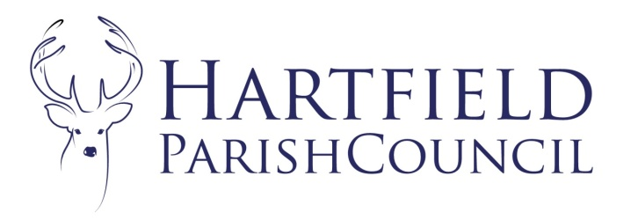
Clerk to the Council: Emma Fulham
Goods Yard House
Edenbridge Road, Hartfield, TN7 4JG
01342 822404
parishclerk@hartfieldonline.com

3rd February 2026

To Whom It May Concern

Reference: Hartfield Parish Council Grants.
Grants: The Parish Council will be awarding annual grants again this year upon written request, and has allocated in the budget an amount for grants. If there is a specific item or project that your organisation is struggling to finance, please write to me by 28th March 2026 using the enclosed application form. Please also enclose a copy of your latest set of accounts. The Parish Council consider all the grant requests together, so please try to ensure that your request is made by this date. If, however, you feel that you have sufficient funds to meet your requirements, please be assured that the funds will be allocated to those organisations that urgently need them.
Annual Parish Meeting: The Parish Council will be holding an Annual Parish Meeting on 13th April 2026. A report on activities for your organisation is always welcome to support the grant application. If you wish to have a stand at the meeting to showcase your organisation’s activities please contact me ASAP to reserve a space.
I hope that you will be able to attend and everyone will be welcome.
Many thanks.
Yours Sincerely

Emma Fulham
Clerk to Hartfield Parish Council.
Enc.

