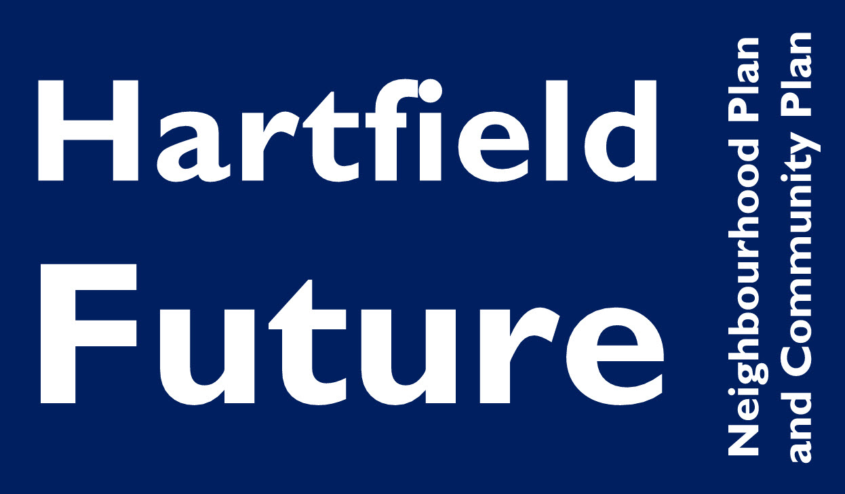
Neighbourhood Plan Meeting 16th October 2013 7:30pm
at Goods Yard House Hartfield TN7 4JG

Present: Kevin Hawes, Laura Hatch, Jo Edwarde, Claire Risby, Nancy Holmes, Monty Larkin, Mark Weaver and Edward Stenhouse
Apologies: Charlotte Beare, Dan Maher, Faye Horsman and John van Maurik
In attendance: Emma Fulham Clerk to Hartfield Parish Council
Introduction
Kevin Hawes reviewed recent progress and thanked Laura Hatch for her analysis of the questionnaires. Mark Weaver said the report produced from the questionnaire responses was a factual and balanced review.
It was agreed to review the summary of responses sent electronically prior to the meeting and agree some action points to progress each of the topics.
- Housing Development
A definite need was identified from responses particularly for downsizer and starter homes.
Various locations were suggested by respondents. For elderly residents downsizing it was felt necessary to identify village centre locations to avoid dependence on private transport. It is more likely that young working people will have access to transport so starter homes to buy could be distributed around the parish, including the hamlets. If there is a clear demand for any additional social housing it should be “pepper potted” within other development rather than expanding existing developments but would need to be in locations served by public transport.
At the meeting it was felt possibly the younger members of the Parish had not expressed their preferences and it was hoped they could be engaged to comment in future consultation.
- Business and Employment
Support for business development was less clear in the survey feedback than the need for certain types of housing. After a discussion it was agreed that more details were required from the questionnaire. but Additional questions will need to be developed to differentiate between different types of business and get more evidence.
Mark Weaver agreed to forward the WDC ‘Streets Ahead’ Paper to the group for information.
- Tourism
The majority of questionnaire responses supported continuing with the current level of tourism but would support a better welcome for tourists through measures such as improved signage..
It was agreed that measures to support tourism such as improved signage would be best dealt with under the Community Plan. There is no clear support for new development in support of tourism, other than conversion of existing buildings for holiday accommodation, which is already possible under the current Local Plan.
- Design and Conservation Area.
There had been some concern over cheap looking new builds although most questioned seemed happy with the design of recent developments.
It was generally agreed by respondents that the Conservation Area should remain traditional. Respondents were more open to contemporary or sustainable designs outside the conservation area.
It was agreed by the group at the meeting that with new permitted development rules Ie.g. for house extensions) a Design Guide for the whole Parish of Hartfield could not be adopted but that a review and update on the Hartfield Village Conservation Area Statement and Guidance should be undertaken.
- Local Facilities and Assets of Community Value
Prior to the meeting a form with assets had been electronically circulated.
It was agreed at the meeting to extend the schedule to identify those in public and those in private ownership where there could be a public interest to buy.
Other assets that would not be candidates for community purchase should also be listed in a schedule, to ensure that they are taken into account in the event of any development that might affect them.
- Car Parking
There was some concern over parking from respondents but little interest in planning a permanent car park.
It was agreed the Community Plan could review options to provide better event parking solutions.
- Action Points
Housing
It was agreed that the group should progress with WDC the availability of demographic data and to mapping of transport links etc before reviewing broad areas for more detailed research into options available for allocation of potential sites new developments.
Mark Weaver and Kevin Hawes would arrange a date to meet WDC in Hailsham to commence the initial review. This date would be circulated should others wish to attend.
Design
It was agreed that other members of the Neighbourhood Plan group should be contacted for volunteers to review the current Conservation Area Guide and report back.
The Clerk would contact the group to ask for volunteers.
Business
It was agreed more information was needed from the public and businesses.
Possible business meetings could be arranged to find out local business needs.
It was agreed to review and agreed further action on this by email.
Asset List
A more comprehensive list was required by the group.
Laura Hatch agreed to provide this.
- Consultation
It was agreed to keep in touch via email with the whole group with a view to meeting prior to a possible business meeting and after the WDC meeting on housing. Clerk to circulate a distribution list.
It was also agreed another public meeting to consult with the Parish would be required. A date to be agreed in April 2014 was considered appropriate. Potential dates that the village hall is available to be investigated.
It was also agreed that a further public mailing could be arranged with agreement on email. If it is to be circulated with the Parish Council newsletter it would need to be sent out early December.
- Work Streams
The potential “work streams” or sub-projects for the Neighbourhood Plan can now be summarised as:
A/ Housing Development: Downsizing and independent living for elderly residents, starter homes for purchase and affordable housing for rental or shared equity
B/ Business Development: Scope to be clarified based on further input
C/ Conservation Area: Updated Design Guide
D/ Assets of Community Value
Work streams to be passed over to the Community Plan are Tourism and Car Parking
- Schedule
Email communications between group members before December to determine additional questions for public consultation.
December 2013 – next mailing to the public
January to March 2014 – draft proposals prepared
April 2014 – public consulation meeting in village hall.

Meeting concluded at 9:20pm

