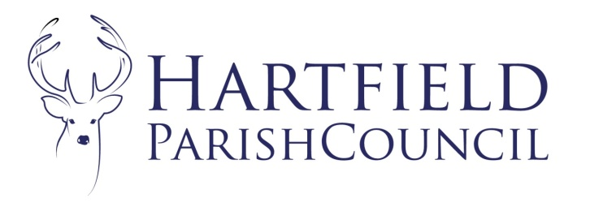
Clerk to the Council: Emma Fulham
Goods Yard House
Edenbridge Road, Hartfield, TN7 4JG
01342 822404
parishclerk@hartfieldonline.com

20th April 2026

To: The Councillors of Hartfield Parish Council
You are required to attend the Annual Parish Council Meeting of Hartfield Parish Council to be held on Monday 11th May 2026 at Goods Yard House as 7:30pm
There will be a period of fifteen minutes for questions from members of the public and for reports from County and District Councillors if supplied to be noted.
The AGENDA is as follows:

- To appoint Chairman 2026/27
- Receive Declaration of Acceptance of Office from Chairman
- Election of Vice Chairman for year 2026/27
- To accept apologies for absence.
- Declarations of pecuniary and disclosable interests in respect of matters to be discussed.

- To Approve Minutes from Parish Council meeting held on 2nd March 2026.

- Matters Arising.
- To consider co-option to the Council.
- Appointment of Committees and Representatives to other Authorised Bodies

- To approve the following Council documents:
- Council Standing Orders.
- Council Financial Regulations.
- Code of Conduct.
- Council published policies.
- Power of General Competence

Part 1 of the Localism Act 2011 applies a general power of competence to local authorities in England.
Section 1 (1) of the Act provides that “a local authority has power to do anything that individuals
generally may do”. The power extends to ‘eligible’ parish councils. Under the Parish Councils (General
Power of Competence) (Prescribed Conditions) Order 2012 (SI 2012/965), an ‘eligible’ parish council is
one in which at least two-thirds of the members have been elected (i.e. not co-opted), and in which the
clerk has completed one of a specified range of training courses.
Recommendations:-
(a) To confirm that Hartfield Parish Council has a Clerk with a Certificate in Local Council
Administration including the General Power of Competence and that two thirds of the Council has been elected.
(b). To adopt the Power of General Competence.

- Correspondence.
- Finance
- To receive and approve the internal audit report
- To approve the AGAR – Accounting Statements
- To approve the AGAR – Accounts 2025/26
- To approve the bank reconciliation for 2025/26
- To approve regular payment schedule and direct debits for 2026/27
- To approve signatories and banking arrangements for 2026/27
- To accept the account summary 2026/27
- To approve expenditure as itemised on the schedule.

- To ratify Committee Minutes
- Planning – March and April.

- To consider expenditure to progress Pooh sculpture project.
- To consider update on Pooh centenary.
- To consider update and proposed expenditure on Jim Lusted memorial and consider a memorial for John Chalke.
- To consider Weald to Waves Initiative. Weald to Waves | Connecting nature across Sussex
- Items for Reporting or Inclusion in Future Agendas.

Dates of Next Meetings:
Parish Council Meeting 1st June 2026

