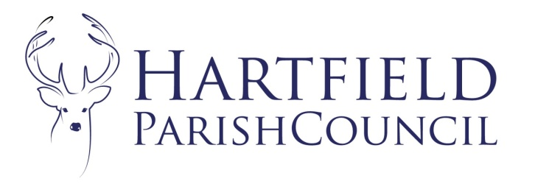
Clerk to the Council: Emma Fulham
Goods Yard House
Edenbridge Road, Hartfield, TN7 4JG
01342 822404
parishclerk@hartfieldonline.com

Minutes to the Parish Council Meeting held in Goods Yard House at 7:30pm on 2nd February 2026.
Present: Cllrs Horner (GH) (Chair), Hutcheson (JH), Norman (PN), Nathan (RN), Colenutt (MC), Baker (PB).
Absent: Cllrs Crosby (KC), Smith (JS), Reed (NR) and Sanders (JS).

In Attendance: Emma Fulham Clerk to the Council.

Public: 0 members of the public was present.
Public Meeting:
Public
There were no questions as there were no public present
Reports from District and County Councillors.
District Councillor Millward reported by email. The main thing she noted was that she still has money to spend within Hartfield ward for community projects that support nature/climate initiatives or community resilience and wellbeing. Grants between £250 and £5000.
In respect of SE Water, it was noted that they will attend the Wealden overview and scrutiny panel on March 30th and Cllr Millward is very happy to take questions from councillors to that meeting.
County Cllr Taylor also reported by email. She had recently attended a meeting about the new Mayoral Authority. The interim Chief Executive and a team is in place to develop the governance, operational areas, budget and strategy. Work is happening at pace, and the Sussex Mayoral Authority will receive 40% of the original budget for the next two years until the Mayor election takes place in 2028. There are cross party meetings taking place in East Sussex, and the District and Borough Authorities are also included in discussion about the development of the new Authority.
The County Council election has been cancelled. The next local election will be for the Unitary Authority in May 2027. We will hear the shape of the new Unitary Authority in the next couple of weeks.
The emergency response was not well managed by Southeast Water and we need more clarity about roles for local people and Parish Councils. Her feeling is that the Sussex Resilience Forum is too remote from communities, and the response did not work well. We need to build better for the next emergency situation. Friends of the River Medway held a meeting in Forest Row to identify and discuss community response to the water outage and to plan for more resilient community. They will be holding follow on meetings in the next week or two.
She has identified 17 badly blocked drains on two main roads in Forest Row last week with the assistant Parish Clerk and a resident. If this kind of situation is also happening in Hartfield please do let me know and She will organise for the same kind of walkabout. She is aware of the blocked drain on Castlefields reported. She thought this had been cleared, so if it was, the build up of a blockage has happened quite rapidly. She will ask the Steward to inspect this again as there is probably an underlying issue. She is also aware of blocked drains outside Oaklea Court and Pooh Corner, which have been reported, but again, She will chase up.
She is also aware that there is a recurring pothole on the High Street at the entrance to the Croft. She will keep chasing these and report back.

Parish Council Meeting commenced at 7:35pm.
There were 0 members of the public present for the main meeting.
- To accept apologies for absence.
Cllrs Crosby (KC), Smith (JS), Reed (NR) and Sanders (JS).
- Declarations of pecuniary and disclosable interests in respect of matters to be discussed.

The Chair reminded Cllrs to declare when necessary.
- To Approve Minutes from Parish Council meeting held on 1st December 2025.

The Council resolved to approve the minutes and they were signed as a true record.
- Matters Arising.
None.
- To consider co-option to the Council.
This item was deferred.
- Correspondence.
The list had been circulated prior to the meeting.
- Finance
- To accept the account summary 2025/26
Unanimously resolved to accept the summary.
- To approve expenditure as itemised on the schedule.
Unanimously resolved to accept the list totalling £39394.00
- To consider movements of reserves
Unanimously resolved to accept the summary and resolved to make the following movements:
To Streetlights £500
To Goods Yard House Contingency £1000
To Playground £1000
To Honey Run £500
The Council deferred any decisions on the CIL fund pending a breakdown of CIL money held.

- To consider banking arrangements
The Council resolved to open a new savings account with Unity Bank.
The Council deferred the option to extend its savings in CCLA.
- To approve risk assessment
Unanimously resolved to accept the summary.
- To approve bank reconciliation
Unanimously resolved to accept the reconciliation and signed accordingly.
- To approve asset list
Unanimously resolved to accept the summary.
- To adopt IT policy to comply with new audit regulations
Unanimously resolved to accept the policy.

- To ratify Committee Minutes
- Planning – December
Unanimously resolved to ratify the minutes.

- Items for Reporting or Inclusion in Future Agendas.

For reporting:

- Update on Pooh sculpture project.

For Inclusion:
- Gatwick
- Co-option
- CLIF grant
- EV Charging
- Pooh Centenary
- War memorial quote
- CIL reconciliation
- John Chalke memorial
- Annual meeting arrangements / volunteer award.

Dates of Next Meetings:
2nd March 2026.

The meeting closed at 9:05pm

