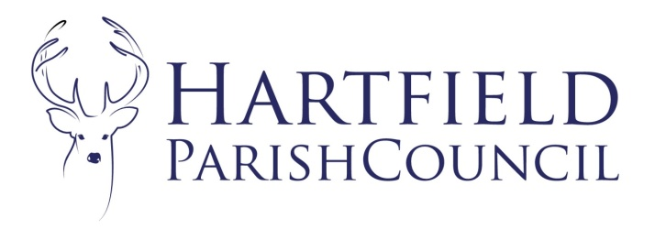
Clerk to the Council: Emma Fulham
Goods Yard House
Edenbridge Road, Hartfield, TN7 4JG
01342 822404
parishclerk@hartfieldonline.com

17th February 2024

To Whom It May Concern

Reference: Hartfield Parish Council Grants.
Grants: The Parish Council will be awarding annual grants again this year upon written request, and has allocated in the budget an amount for grants. If there is a specific item or project that your organisation is struggling to finance, please write to me by 27th March 2024, using the enclosed application form. Please also enclose a copy of your latest set of accounts. The Parish Council consider all the grant requests together, so please try to ensure that your request is made by this date. If, however, you feel that you have sufficient funds to meet your requirements, please be assured that the funds will be allocated to those organisations that urgently need them.
Annual Parish Meeting: The Parish Council will be holding an Annual Parish Meeting on 15th April 2024. A report on activities for your organisation is always welcome to support the grant application and we can add them to our annual report for wider distribution but please ensure any reports are sent electronically to me by 27th March 2024. If you wish to have a stand at the meeting to showcase your organisation’s activities please contact me ASAP to reserve a space.
I hope that you will be able to attend and everyone will be welcome.
Many thanks.
Yours Sincerely

Emma Fulham
Clerk to Hartfield Parish Council.
Enc.

